list of mail servers
# Source: AI Source: Provided by: [Data Path: Persons Table -> ID Column: 1, Name_En Column: Motasem Essam] -> From: [ChatGPT] on [1/21/2026]
Here’s a categorized list of the most widely used mail servers — both for personal use, business, and bulk/transactional emailing.

💼 1. SMTP Servers by Popular Providers (Free or Personal Use)
# Source: AI Source: Provided by: [Data Path: Persons Table -> ID Column: 1, Name_En Column: Motasem Essam] -> From: [ChatGPT] on [1/21/2026]
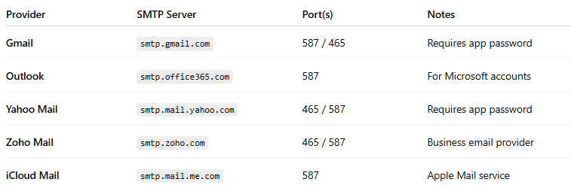

Provider | SMTP Server | Port(s) | Notes
Gmail | smtp.gmail.com | 587 / 465 | Requires app password
Outlook | smtp.office365.com | 587 | For Microsoft accounts
Yahoo Mail | smtp.mail.yahoo.com | 465 / 587 | Requires app password
Zoho Mail | smtp.zoho.com | 465 / 587 | Business email provider
iCloud Mail | smtp.mail.me.com | 587 | Apple Mail service

🚀 2. Transactional / Bulk Email Services (SMTP or API)
# Source: AI Source: Provided by: [Data Path: Persons Table -> ID Column: 1, Name_En Column: Motasem Essam] -> From: [ChatGPT] on [1/21/2026]
These are designed for high-volume, reliable email sending, with support for tracking, retries, and reputation management.
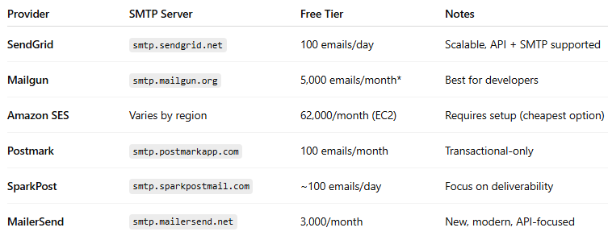

Provider | SMTP Server | Free Tier | Notes
SendGrid | smtp.sendgrid.net | 100 emails/day | Scalable, API + SMTP supported
Mailgun | smtp.mailgun.org | 5,000 emails/month* | Best for developers
Amazon SES | Varies by region | 62,000/month (EC2) | Requires setup (cheapest option)
Postmark | smtp.postmarkapp.com | 100 emails/month | Transactional-only
SparkPost | smtp.sparkpostmail.com | ~100 emails/day | Focus on deliverability
MailerSend | smtp.mailersend.net | 3,000/month | New, modern, API-focused

🖥️ 3. Self-Hosted Mail Servers (Run on Your Own Server)
# Source: AI Source: Provided by: [Data Path: Persons Table -> ID Column: 1, Name_En Column: Motasem Essam] -> From: [ChatGPT] on [1/21/2026]
These are mail server applications you can host yourself on VPS or dedicated servers. Useful for advanced setups.
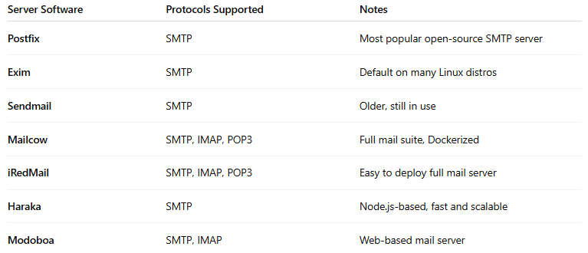

Server Software | Protocols Supported | Notes
Postfix | SMTP | Most popular open-source SMTP server
Exim | SMTP | Default on many Linux distros
Sendmail | SMTP | Older, still in use
Mailcow | SMTP, IMAP, POP3 | Full mail suite, Dockerized
iRedMail | SMTP, IMAP, POP3 | Easy to deploy full mail server
Haraka | SMTP | Node.js-based, fast and scalable
Modoboa | SMTP, IMAP | Web-based mail server
⚠️ Self-hosted mail servers are difficult to manage and require DNS, SPF/DKIM, reverse DNS, etc. Misconfiguration can lead to spam or blacklisting.

🧠 Summary
# Source: AI Source: Provided by: [Data Path: Persons Table -> ID Column: 1, Name_En Column: Motasem Essam] -> From: [ChatGPT] on [1/21/2026]
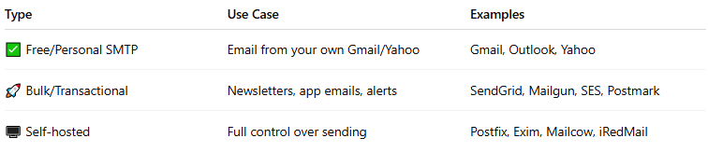

Type | Use Case | Examples
✅ Free/Personal SMTP | Email from your own Gmail/Yahoo | Gmail, Outlook, Yahoo
🚀 Bulk/Transactional | Newsletters, app emails, alerts | SendGrid, Mailgun, SES, Postmark
🖥️ Self-hosted | Full control over sending | Postfix, Exim, Mailcow, iRedMail

